**612/6**

IPS ART & CRAFT

**STUDIO TECHNOLOGY**

**(Crafts B)**

**Paper 6**

**Jul/ Aug 2019**

5 ¼ hours

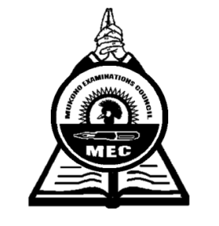

**MUKONO EXAMINATION COUNCIL**

**Uganda Certificate of Education**

IPS ART AND CRAFT

STUDIO TECHNOLOGY (CRAFT B)

**Paper 6**

Planning 2 ¼ hours

Practical examination 3 hours

**INSTRUCTIONS TO CANDIDATES**

*This paper consists of* ***three*** *sections* ***A, B*** *and* ***C***

*Answer* ***one*** *question from any section stating its number.*

*Use of relevant illustrations will earn you credit.*

**SECTION A**

1. Develop a motif for a pattern to be transferred onto a white cloth measuring 50 square cm using three co-joined geometric shapes as a source of inspiration.

Printing technique should be used to design the fabric

1. (a) On a washed, dried and ironed fabric (one square meter), trace a design which you have derived from nature ( Pawpaw, Passion fruit, Flower, insect or Bird) or lines

(b) Heat wax to a liquid form to use it to wax the areas you intend to remain in the colour of the fabric

(c). Apply the first dye and hang the fabric to dry

(d) Wax the second area you intend to remain in the first colour and then dye the fabric in the second colour. Hang the fabric to dry again.

(e) Remove the wax thoroughly by washing the fabric in cold water while rubbing vigorously.

Use white spirit to remove excess wax.

**SECTION B**

1. Within an area of 18cm x 32 cm, design a collage suitable for a wall hanging.

The collage should depict a landscape that captures hills, tress and lake scenery.

First draw your picture with a faint pencil, choose the media suitable for each boundary, glue and paste the media as required.

Design a boundary around your collage with any materials provided by the Art teacher.

1. Using materials provided, make a set of ornaments (one necklace, a pair of earrings, and two bungles), portraying the African culture.

**SECTION C**

1. With plastic clay, make a mold of either an animal face or alien. Upon this clay mold, using either cassava paste or glue make a mask out of pieces of paper.
2. Make a flower vase from clay suitable for a fountain. Develop your concept from fish

Show the development of your idea through sketches.

1. Using either a dry soft cylindrical piece of wood (approx.30cm) or a piece of wax block or soap curve an abstract piece of sculpture that depicts unity.

***End -***